01.08
Weight and Balance
Process Design & AMOS Configuration Document
Purpose
This Process Design document is provided to Key-Users to record their key decisions regarding the AMOS Process design and the required AMOS configuration.
It is updated throughout the Project Definition Phase and used as the baseline for the Final Acceptance prior to Go-Live
Revision
Author, Name | Date | Notes
Boris Kazarow | 01.06.2024 | First Version
Boris Kazarow | 18.12.2024 | Second Version  Ch. 6: Updated Flowchart

Table of Contents
1. Process Overview & Objectives 3
2. Regulatory References 3
3. Definitions & Glossary 5
4. Process Tasks 5
5. Process Dependencies 5
6. Process Flow 6
7. Process Design Questions 7
8. Data (Source) Mapping 8
9. Other Software Used 8
10. AMOS Configuration 9
a. Basic Data 9
b. Parameters 9
c. Workflows 9
d. Scheduled Tasks 9
e. API’s & Interfaces 9
11. UAT Guidance 10
12. Annex – Additional Info 10

Process Overview & Objectives

Process General Description:
There are many factors in the safe and efficient operation of aircraft, including proper weight and balance control. The weight and balance system commonly employed among aircraft consists of three equally important elements: Weighing of the aircraft, maintaining the weight and balance records, and the proper loading of the aircraft. An inaccuracy in any one of these elements defeats the purpose of the system. The final loading calculations are meaningless if either the aircraft has been improperly weighed or the records contain an error. Improper loading decreases the efficiency and performance of an aircraft from the standpoint of altitude, manoeuvrability, rate of climb, and speed. It may even be the cause of failure to complete the flight or, for that matter, failure to start the flight. Because of abnormal stresses placed upon the structure of an improperly loaded aircraft, or because of changed flying characteristics of the aircraft, loss of life and destruction of valuable equipment may result.
Main Process Objective (Outputs & Outcomes) :
This process is to set up weight and balance characteristics for an A/C or group multiple aircraft to the same characteristics, to record weighing entries, track weight & moment changes throughout the aircraft maintenance cycle and to calculate the CoG location and MAC impacts.
Through workflow settings users can be informed following a weight & balance value update if:
- CoG moves beyond predefined limits (%MAC min/max, %MAC margin min/max)
- Operating weight deviates more than a predefined limit from the fleet basic weight
- If the distance of the CoG and the fleet’s CoGs moves more than a predefined margin from the MAC.
The Fleet Envelope chart allows monitoring the CoG location against other aircraft of the same W&B fleet characteristics (same fleet code) and if it has moved more than 0.5% of the fleet’s CoG. Moreover, an optimized position (average of all aircraft’s values) can be calculated for a possible new definition of limits. This point can serve as a basis to bring all aircraft back into the limits.

Regulatory References

EASA:
- Regulation (EU) No 1321/2014 - Continuing Airworthiness

Part M - Continuing Airworthiness Requirements

  - M.A.306 Aircraft technical log system: This section requires operators to maintain a technical log system, which includes details of any changes affecting the aircraft's weight and balance.
  - M.A.305 Aircraft continuing airworthiness record system: This section mandates the maintenance of records for all continuing airworthiness activities, including weight and balance data.

Part 145 - Maintenance Organisations

  - 145.A.55 Maintenance records: This section requires maintenance organizations to keep detailed records of all work performed, including any changes that affect the aircraft's weight and balance.

FAA:
- 14 CFR Part 91 - General Operating and Flight Rules

  - § 91.9 Civil aircraft flight manual, marking, and placard requirements: This section requires operators to comply with the aircraft flight manual, which includes weight and balance information.
  - § 91.103 Preflight action: This section mandates that pilots must be familiar with all available information concerning the flight, including weight and balance data.

- 14 CFR Part 121 - Operating Requirements: Domestic, Flag, and Supplemental Operations

  - § 121.153 Aircraft requirements: General: This section specifies that each certificate holder must maintain the aircraft in an airworthy condition, which includes adhering to weight and balance requirements.
  - § 121.663 Responsibility for operational control: Domestic and flag operations: This section states that operators must ensure the aircraft is properly loaded and within weight and balance limitations.
  - § 121.665 Load manifest: This section requires operators to prepare a load manifest before each takeoff, which includes weight and balance data.
  - § 121.693 Load manifest: All certificate holders: This section outlines the specific information that must be included in the load manifest, such as weight and balance calculations.
  - § 121.701 Maintenance log: Aircraft: This section requires operators to maintain accurate maintenance logs, which include weight and balance changes resulting from maintenance actions.
  - 14 CFR Part 135 - Operating Requirements: Commuter and On Demand Operations and Rules Governing Persons On Board Such Aircraft
  - § 135.63 Recordkeeping requirements: This section mandates that operators maintain records of weight and balance computations for each flight.

- 14 CFR Part 43 - Maintenance, Preventive Maintenance, Rebuilding, and Alteration

  - § 43.13 Performance rules (general): This section requires that maintenance and alterations be performed in such a manner that the aircraft continues to meet its type design, including weight and balance limitations.
  - § 43.5 Approval for return to service after maintenance, preventive maintenance, rebuilding, or alteration: This section ensures that the aircraft is in compliance with all applicable regulations, including weight and balance requirements, before being returned to service.

Definitions & Glossary

Key-Words | Explanation
OEW | Operative Empty Weight
CoG | Center of Gravity
MTOW | Maximum Take-off Weight
MAC | Mean Aerodynamic Chord
LEMAC | Leading Edge Aerodynamic Chord

Process Tasks

Business Process Task / Actions / Activities:
- Set up Weight & Balance characteristics for one aircraft
- Set up Weight & Balance characteristics for a Fleet Code and group multiple aircraft to it
- Set up Weight & Balance characteristics for a specific Cabin Version and assign one or more aircraft to it
- Record Weight & Balance change following a (scheduled) maintenance event manually
- Set up a document in APN 63 with W&B impact, execute it and examine W/B record changes
- Monitor Fleet Envelope and

Process Dependencies
INPUT | CONCURRENT | OUTPUT
- 02.01 – Aircraft Phase in: New A/C joining the fleet requires W&B setup and initial weighing | - 01.03 – Maintenance Program: Weight Change after execution of scheduled weighing task  - 01.04 – SB & AD Assessment: Weight Change after execution of a Modification Document

Process Flow
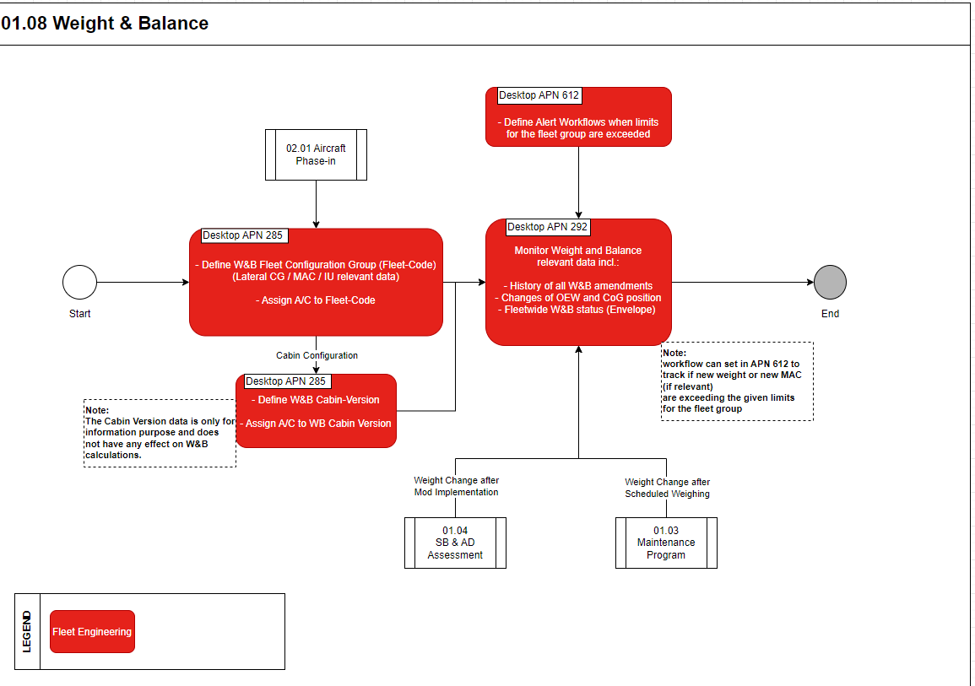

Process Design Questions

# | Question | Answer
1 | Who is in charge to control W&B and who defines the fleet group codes?
2 | How do you update W&B after a modification or major repair?
3 | How often do you perform W&B updates?
4 | Do you perform fleet weighing?
5
6

Data (Source) Mapping

Data Sources | Description | Volume / Manual / Automatic / Static / Dynamic

Other Software Used

Other Softwares | Used by: | Description

AMOS Configuration

Basic Data

Basic Data Table | Notes
Cabin Interior Type
Rating Category (Weight…)

Parameters

Parameter Code | Parameter Name | Notes
1239 | WEIGHT&BALANCE: ENABLE VALUE CHANGES  (Defines number of decimal digits of W&B values)

Workflows

Workflow Number | Workflow Name | Notes
20 | Check new weight
367 | After new weight

Scheduled Tasks

Scheduled Task Reference | Frequency | Notes
-/- | -/- | -/-

API’s & Interfaces

Reference | Direction | Trigger | Frequency
-/- | -/- | -/- | -/-

UAT Guidance

No | Proposed User Acceptance Test scenario
1 | Create Weight & Balance data for an aircraft
2 | Create Weight & Balance characteristics for a fleet group code and assign multiple A/C to it
3 | Create Cabin Version and assign A/C to it
4 | Create modification document bringing about a W&B change. Execute, report it back and check W&B change
5 | Perform aircraft weighing through MP Task Card and record weighing data

Annex – Additional Info

